1. The XRD patterns of the Langdai and Chinahe K-bentonites whole-rock samples and their clay fractions with varied treatments (**from Raw XRD data**)

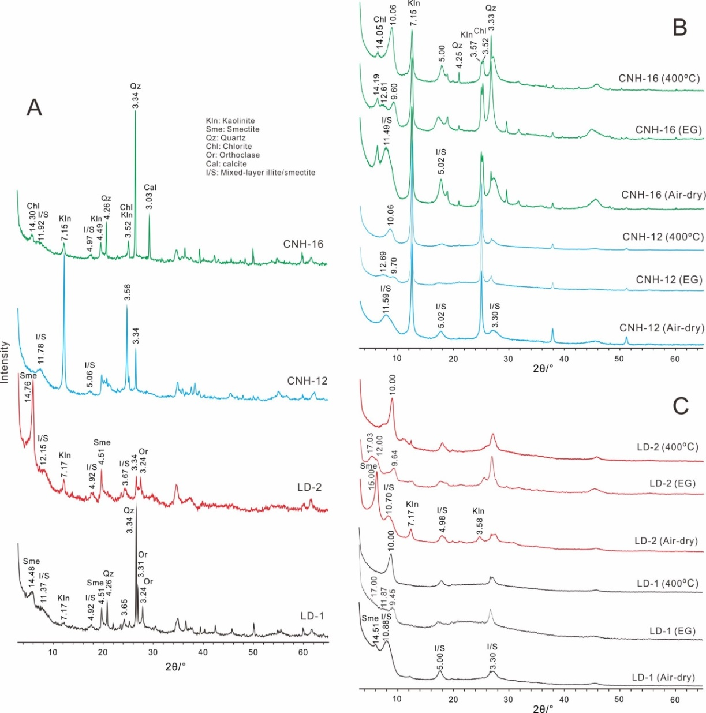

2. The fitting XRD patterns of glycolated clay fractions of the Langdai and Chinahe K-bentonites (**from fitting Raw XRD data**)

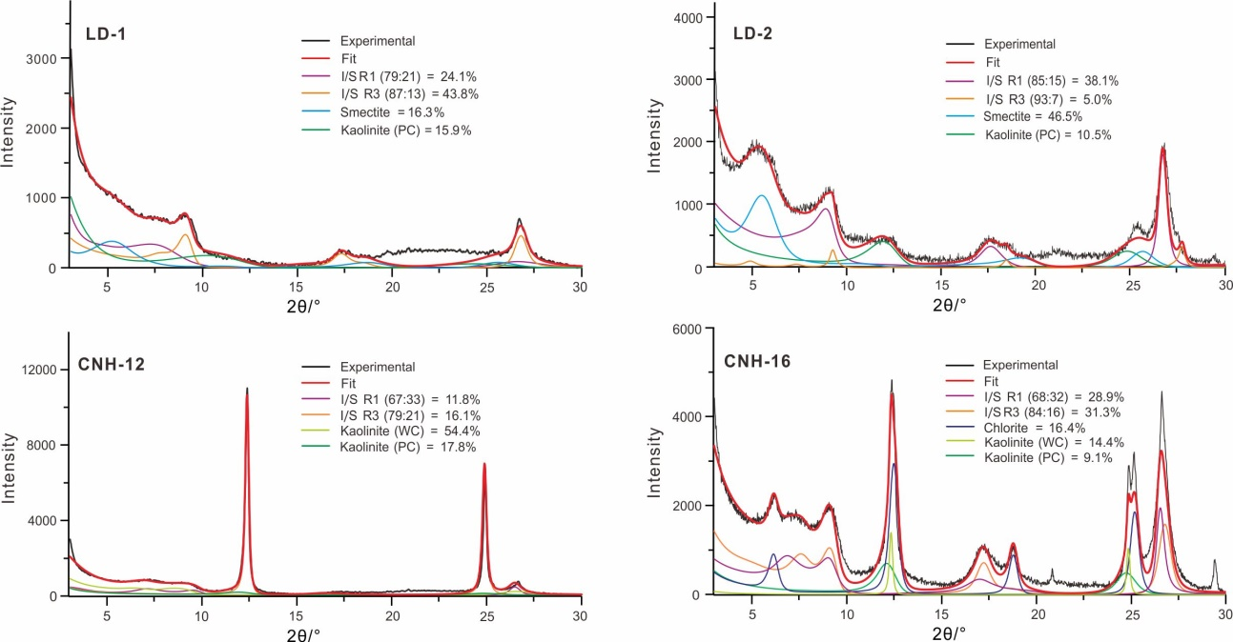

3. Environment-dependent morphologies of authigenic anatase crystals in K-bentonites

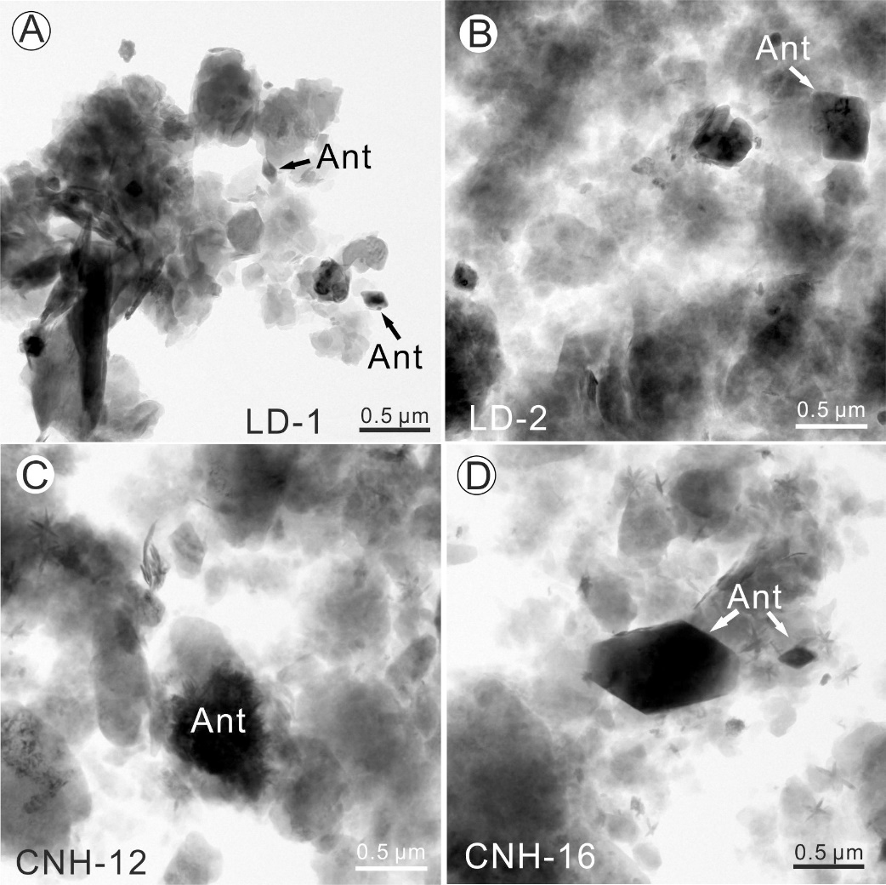

4. Table 1. Major chemical compositions of K-bentonite and some neighbouring siltstone samples (all values are wt%)

|  |  |  |  |  |  |  |  |  |  |  |  |  |  |  |
| --- | --- | --- | --- | --- | --- | --- | --- | --- | --- | --- | --- | --- | --- | --- |
|  | SiO2 | TiO2 | Al2O3 | Fe2O3 | MnO | MgO | CaO | Na2O | K2O | P2O5 | LOI | SUM | Section | References |
| JCC-1 | 51.38 | 0.52 | 27.14 | 2.54 | 0.10 | 2.34 | 0.13 | 0.00 | 6.49 | 0.04 | 9.69 | 100.37 | Jiucaichong | Hong et al., 2019 |
| CH-2 | 48.74 | 0.71 | 26.43 | 7.54 | 0.24 | 1.31 | 0.27 | 0.02 | 5.30 | 0.11 | 9.17 | 99.84 | Chahe | Gong et al., 2018 |
| CH-1 | 57.47 | 2.62 | 21.61 | 3.73 | 0.00 | 0.79 | 0.31 | 0.00 | 4.45 | 0.05 | 9.42 | 100.45 | Chahe | Gong et al., 2018 |
| TC-2 | 51.18 | 4.42 | 26.78 | 3.87 | 0.01 | 0.40 | 0.07 | 0.00 | 0.82 | 0.16 | 12.83 | 100.54 | Tucheng | Hong et al., 2017 |
| TC-1 | 49.58 | 4.75 | 28.85 | 3.42 | 0.01 | 0.43 | 0.09 | 0.00 | 0.84 | 0.15 | 12.45 | 100.57 | Tucheng | Hong et al., 2017 |
| ZJ-2 | 46.90 | 6.47 | 30.50 | 2.11 | 0.02 | 0.43 | 0.17 | 0.13 | 1.97 | 0.06 | 11.67 | 100.43 | Zhejue | Hong et al., 2017 |
| ZJ-1 | 47.78 | 6.34 | 29.53 | 2.28 | 0.01 | 0.53 | 0.19 | 0.07 | 1.58 | 0.19 | 11.90 | 100.40 | Zhejue | Hong et al., 2017 |
| CNH-16b | 49.14 | 2.36 | 13.67 | 12.38 | 0.28 | 3.05 | 6.20 | 0.18 | 2.00 | 0.33 | 8.79 | 98.39 | Chinahe | This study |
| CNH-16 | 47.20 | 2.07 | 16.25 | 7.01 | 0.25 | 2.36 | 9.03 | 0.04 | 3.02 | 0.29 | 11.32 | 98.84 | Chinahe | This study |
| CNH-12b | 45.10 | 4.65 | 18.02 | 16.86 | 0.72 | 1.39 | 1.59 | 0.03 | 1.53 | 0.57 | 9.82 | 100.26 | Chinahe | This study |
| CNH-12 | 47.99 | 0.99 | 33.00 | 3.01 | 0.01 | 0.48 | 0.56 | 0.03 | 2.39 | 0.20 | 10.99 | 99.64 | Chinahe | This study |
| LD-2b | 51.57 | 2.30 | 16.28 | 10.67 | 0.13 | 4.82 | 2.69 | 0.89 | 4.06 | 0.43 | 5.65 | 99.48 | Langdai | This study |
| LD-2 | 47.14 | 1.20 | 18.58 | 13.02 | 0.14 | 5.43 | 2.14 | 0.21 | 4.32 | 0.21 | 7.52 | 99.92 | Langdai | This study |
| LD-1b | 58.47 | 2.54 | 14.98 | 9.28 | 0.48 | 1.77 | 1.41 | 2.87 | 2.60 | 0.52 | 4.35 | 99.26 | Langdai | This study |
| LD-1 | 53.83 | 1.18 | 21.64 | 5.74 | 0.12 | 3.27 | 1.37 | 0.62 | 4.95 | 0.23 | 6.64 | 99.59 | Langdai | This study |
| ZZ-2 | 52.14 | 0.94 | 20.30 | 5.19 | 0.28 | 3.23 | 1.33 | 0.04 | 4.14 | 0.12 | 12.75 | 100.46 | Zhongzhai | Hong et al., 2017 |
| ZZ-1 | 54.79 | 0.56 | 20.34 | 3.30 | 0.45 | 3.22 | 1.85 | 0.07 | 3.76 | 0.13 | 12.03 | 100.50 | Zhongzhai | Hong et al., 2017 |

5. Table 2. Concentrations of trace elements and REEs of K-bentonite and some neighbouring siltstone samples (all values are 10−6)

|  |  |  |  |  |  |  |  |  |  |  |  |  |  |  |  |  |  |  |  |  |  |  |  |  |  |  |  |  |  |  |  |  |  |  |  |  |  |  |
| --- | --- | --- | --- | --- | --- | --- | --- | --- | --- | --- | --- | --- | --- | --- | --- | --- | --- | --- | --- | --- | --- | --- | --- | --- | --- | --- | --- | --- | --- | --- | --- | --- | --- | --- | --- | --- | --- | --- |
|  | Li | Be | | Sc | V | | Cr | | Co | | Ni | | Cu | | Zn | | Ga | | Rb | | Sr | | Y | | Zr | | Nb | | Sn | | Cs | Ba | La | Ce | Pr | | Nd | Sm |
| JCC-1 | 37.2 | 1.83 | | 7.73 | 18.4 | | 4.92 | | 6.02 | | 19.1 | | 16.1 | | 60.5 | | 17.0 | | 67.5 | | 318 | | 54.2 | | 340 | | 15.3 | | 6.40 | | 8.21 | 37.4 | 74.5 | 131 | 15.7 | | 58.8 | 12.1 |
| CH-2 | 1.62 | 5.08 | | 32.6 | 265 | | 214 | | 5.25 | | 28.2 | | 132 | | 27.2 | | 28.8 | | 105 | | 35.5 | | 132 | | 295 | | 31.9 | | 3.00 | | 3.01 | 108 | 222 | 341 | 84.4 | | 361 | 76.7 |
| CH-1 | 3.14 | 3.36 | | 15.8 | 33.2 | | 13.0 | | 14.7 | | 25.6 | | 128 | | 45.8 | | 34.9 | | 226 | | 22.6 | | 59.0 | | 554 | | 31.8 | | 10.7 | | 11.8 | 163 | 31.3 | 86.4 | 12.4 | | 53.2 | 12.2 |
| TC-2 | 19.5 | 3.27 | | 27.1 | 293 | | 83.4 | | 7.96 | | 58.9 | | 126 | | 45.8 | | 34.8 | | 33.2 | | 272 | | 79.8 | | 555 | | 57.8 | | 5.11 | | 1.97 | 403 | 105 | 213 | 30.7 | | 130 | 26.4 |
| TC-1 | 20.4 | 2.68 | | 26.2 | 272 | | 75.7 | | 9.08 | | 49.1 | | 123 | | 51.3 | | 34.2 | | 37.0 | | 180 | | 74.2 | | 535 | | 53.3 | | 4.58 | | 1.83 | 292 | 101 | 194 | 28.5 | | 116 | 22.4 |
| ZJ-2 | 34.6 | 2.37 | | 5.61 | 41.7 | | 15.6 | | 6.03 | | 28.8 | | 7.07 | | 19.4 | | 26.1 | | 9.55 | | 12.3 | | 8.83 | | 343 | | 16.6 | | 10.0 | | 0.42 | 36.7 | 11.6 | 20.3 | 2.26 | | 8.20 | 1.51 |
| ZJ-1 | 13.5 | 2.90 | | 35.6 | 385 | | 272 | | 8.05 | | 77.4 | | 144 | | 77.3 | | 34.1 | | 51.3 | | 96.7 | | 68.8 | | 664 | | 53.1 | | 4.38 | | 2.10 | 158 | 112 | 222 | 26.6 | | 100 | 15.6 |
| CNH-16b | 14.2 | 2.76 | | 21.5 | 197 | | 93.3 | | 44.6 | | 63.3 | | 161 | | 105 | | 22.8 | | 82.2 | | 71.3 | | 37.3 | | 308 | | 34.8 | | 4.03 | | 2.25 | 102 | 53.8 | 116 | 14.0 | | 50.5 | 10.4 |
| CNH-16 | 13.8 | 3.58 | | 19.9 | 168 | | 74.3 | | 21.8 | | 40.7 | | 95.6 | | 82.8 | | 24.7 | | 119 | | 101 | | 47.4 | | 358 | | 33.7 | | 4.80 | | 7.16 | 94.5 | 68.0 | 140 | 17.6 | | 67.0 | 13.3 |
| CNH-12b | 40.3 | 3.82 | | 37.9 | 384 | | 159 | | 78.9 | | 116 | | 253 | | 235 | | 35.3 | | 53.3 | | 88.2 | | 57.2 | | 491 | | 66.0 | | 4.71 | | 1.91 | 234 | 81.0 | 182 | 20.7 | | 82.4 | 16.1 |
| CNH-12 | 65.3 | 5.18 | | 25.4 | 68.9 | | 17.8 | | 9.92 | | 18.6 | | 39.8 | | 81.5 | | 32.6 | | 73.9 | | 36.9 | | 62.2 | | 661 | | 34.4 | | 12.0 | | 7.85 | 55.4 | 33.6 | 71.8 | 7.67 | | 28.4 | 6.39 |
| LD-2b | 38.7 | 5.21 | | 20.5 | 194 | | 67.0 | | 30.0 | | 52.2 | | 114 | | 85.1 | | 28.5 | | 186 | | 266 | | 46.1 | | 387 | | 46.8 | | 5.43 | | 5.35 | 541 | 62.8 | 125 | 15.9 | | 62.0 | 13.1 |
| LD-2 | 45.7 | 4.74 | | 15.8 | 210 | | 42.0 | | 30.8 | | 46.5 | | 54.2 | | 102 | | 30.6 | | 245 | | 118 | | 27.1 | | 371 | | 37.1 | | 9.87 | | 13.6 | 342 | 78.5 | 124 | 12.6 | | 43.8 | 8.88 |
| LD-1b | 28.4 | 2.52 | | 20.6 | 207 | | 113 | | 34.1 | | 62.5 | | 95.0 | | 136 | | 23.1 | | 98.4 | | 337 | | 43.3 | | 319 | | 41.4 | | 3.06 | | 3.27 | 545 | 54.3 | 116 | 13.1 | | 53.3 | 11.1 |
| LD-1 | 39.1 | 8.97 | | 31.3 | 141 | | 85.3 | | 17.3 | | 29.6 | | 27.3 | | 64.6 | | 35.4 | | 248 | | 112 | | 87.4 | | 847 | | 37.4 | | 11.5 | | 16.5 | 312 | 156 | 292 | 32.8 | | 108 | 16.8 |
| ZZ-2 | 20.7 | 2.22 | | 26.1 | 90.0 | | 17.3 | | 13.2 | | 18.5 | | 24.1 | | 88.8 | | 29.1 | | 176 | | 35.4 | | 40.5 | | 430 | | 20.9 | | 5.87 | | 5.44 | 143 | 32.2 | 147 | 8.52 | | 31.7 | 8.06 |
| ZZ-1 | 12.6 | 4.24 | | 14.9 | 44.3 | | 26.0 | | 7.06 | | 21.0 | | 19.9 | | 69.0 | | 25.3 | | 138 | | 179 | | 74.0 | | 411 | | 18.5 | | 6.32 | | 7.19 | 137 | 73.7 | 126 | 17.4 | | 64.6 | 13.3 |
|  | Eu | Gd | Tb | | Dy | Ho | | Er | | Tm | | Yb | | Lu | | Hf | | Ta | | Tl | | Pb | | Th | | U | | ∑REE | | ∑LREE | | ∑HREE | | ∑LREE/∑HREE | | References | | |
| JCC-1 | 1.56 | 11.2 | 1.78 | | 10.6 | 2.00 | | 5.44 | | 0.77 | | 4.61 | | 0.65 | | 10.2 | | 1.69 | | 0.27 | | 72.2 | | 33.9 | | 6.52 | | 340.97 | | 293.80 | | 47.17 | | 6.23 | | Hong et al., 2019 | | |
| CH-2 | 19.9 | 63.3 | 7.85 | | 34.9 | 5.32 | | 11.6 | | 1.42 | | 7.52 | | 1.04 | | 7.93 | | 2.01 | | 0.31 | | 6.28 | | 11.2 | | 3.10 | | 805 | | 1237.95 | | 132.95 | | 8.31 | | Gong et al., 2018 | | |
| CH-1 | 3.88 | 11.7 | 1.90 | | 11.0 | 2.11 | | 5.74 | | 0.86 | | 5.67 | | 0.81 | | 17.0 | | 2.97 | | 0.54 | | 2.58 | | 69.9 | | 10.9 | | 239.17 | | 199.38 | | 39.79 | | 5.02 | | Gong et al., 2018 | | |
| TC-2 | 6.74 | 22.2 | 3.14 | | 16.8 | 3.00 | | 7.84 | | 1.10 | | 6.56 | | 0.94 | | 14.4 | | 2.87 | | 0.21 | | 29.0 | | 16.9 | | 4.80 | | 573.32 | | 511.70 | | 61.62 | | 8.30 | | Hong et al., 2017 | | |
| TC-1 | 5.80 | 18.6 | 2.67 | | 14.2 | 2.66 | | 6.92 | | 0.94 | | 5.83 | | 0.85 | | 14.0 | | 3.01 | | 0.13 | | 16.8 | | 16.2 | | 4.69 | | 520.96 | | 468.27 | | 52.68 | | 8.89 | | Hong et al., 2017 | | |
| ZJ-2 | 0.32 | 1.31 | 0.25 | | 1.74 | 0.35 | | 1.09 | | 0.18 | | 1.27 | | 0.19 | | 12.5 | | 2.20 | | 0.04 | | 4.16 | | 38.9 | | 5.21 | | 63.04 | | 44.16 | | 18.89 | | 2.34 | | Hong et al., 2017 | | |
| ZJ-1 | 3.26 | 12.5 | 2.18 | | 13.7 | 2.62 | | 7.24 | | 1.02 | | 6.25 | | 0.87 | | 17.1 | | 3.54 | | 0.16 | | 19.6 | | 20.0 | | 5.13 | | 543.32 | | 479.82 | | 63.50 | | 7.56 | | Hong et al., 2017 | | |
| CNH-16b | 2.58 | 8.90 | 1.32 | | 7.75 | 1.50 | | 3.95 | | 0.53 | | 3.47 | | 0.53 | | 8.29 | | 2.23 | | 0.26 | | 9.53 | | 11.7 | | 2.45 | | 275.5 | | 247.5 | | 28.0 | | 8.85 | | This study | | |
| CNH-16 | 3.36 | 10.4 | 1.58 | | 9.19 | 1.69 | | 4.68 | | 0.65 | | 4.12 | | 0.57 | | 9.73 | | 2.37 | | 0.30 | | 8.21 | | 19.5 | | 4.34 | | 342.6 | | 309.7 | | 32.9 | | 9.40 | | This study | | |
| CNH-12b | 3.63 | 13.5 | 2.05 | | 11.6 | 2.18 | | 5.61 | | 0.73 | | 4.84 | | 0.70 | | 13.2 | | 4.12 | | 0.17 | | 14.4 | | 14.8 | | 3.49 | | 427.3 | | 386.2 | | 41.1 | | 9.39 | | This study | | |
| CNH-12 | 1.57 | 7.28 | 1.52 | | 11.3 | 2.40 | | 6.81 | | 1.02 | | 6.30 | | 0.93 | | 19.9 | | 3.35 | | 0.17 | | 60.2 | | 74.9 | | 13.7 | | 186.9 | | 149.4 | | 37.5 | | 3.98 | | This study | | |
| LD-2b | 3.03 | 10.9 | 1.71 | | 9.06 | 1.68 | | 4.56 | | 0.65 | | 4.11 | | 0.57 | | 10.3 | | 3.13 | | 0.34 | | 7.07 | | 18.5 | | 4.24 | | 315.4 | | 282.1 | | 33.2 | | 8.49 | | This study | | |
| LD-2 | 1.95 | 7.14 | 1.08 | | 5.64 | 1.00 | | 2.60 | | 0.37 | | 2.31 | | 0.31 | | 11.4 | | 3.31 | | 0.37 | | 7.71 | | 42.4 | | 5.94 | | 289.7 | | 269.3 | | 20.5 | | 13.17 | | This study | | |
| LD-1b | 2.55 | 9.19 | 1.30 | | 7.84 | 1.44 | | 3.85 | | 0.53 | | 3.17 | | 0.48 | | 8.40 | | 2.52 | | 0.35 | | 11.2 | | 10.8 | | 3.57 | | 277.9 | | 250.1 | | 27.8 | | 9.00 | | This study | | |
| LD-1 | 4.38 | 12.6 | 2.26 | | 15.4 | 3.20 | | 9.73 | | 1.52 | | 9.73 | | 1.36 | | 23.5 | | 3.81 | | 0.25 | | 7.17 | | 67.7 | | 4.26 | | 666.8 | | 611.0 | | 55.8 | | 10.95 | | This study | | |
| ZZ-2 | 1.71 | 7.44 | 1.33 | | 7.66 | 1.52 | | 4.33 | | 0.63 | | 3.70 | | 0.54 | | 11.7 | | 1.74 | | 0.41 | | 43.8 | | 28.4 | | 4.45 | | 256.06 | | 228.91 | | 27.15 | | 8.43 | | Hong et al., 2017 | | |
| ZZ-1 | 2.83 | 12.8 | 2.17 | | 13.0 | 2.63 | | 7.78 | | 1.14 | | 6.65 | | 0.97 | | 12.0 | | 1.58 | | 0.28 | | 42.6 | | 31.2 | | 4.20 | | 345.39 | | 298.45 | | 47.15 | | 6.33 | | Hong et al., 2017 | | |

6. Table 3. Calculated geochemical indices of K-bentonites and some neighbouring siltstones in terrestrial to littoral environment in in western Guizhou

|  |  |  |  |  |  |  |  |  |  |  |  |
| --- | --- | --- | --- | --- | --- | --- | --- | --- | --- | --- | --- |
|  | CIA | MgO/K2O | MgO/Al2O3 | TiO2/Al2O3 | Sr/Ba | Y/Ho | U/Th | UEF | Sedimentary facies | Section | Note |
| JCC-1 | 79.4 | 0.843 | 0.218 | 0.024 | 0.09 | 27.10 | 0.19 | 1.3 | lacustrine | Jiucaichong |  |
| CH-2 | 82.3 | 0.578 | 0.125 | 0.034 | 0.33 | 24.81 | 0.28 | 0.6 | lacustrine | Chahe |  |
| CH-1 | 82.1 | 0.415 | 0.093 | 0.155 | 0.14 | 27.96 | 0.16 | 2.7 | lacustrine | Chahe |  |
| TC-2 | 96.8 | 1.140 | 0.038 | 0.211 | 0.67 | 26.60 | 0.28 | 1.0 | marine-terrestrial transitional | Tucheng |  |
| TC-1 | 96.9 | 1.196 | 0.038 | 0.210 | 0.62 | 27.89 | 0.29 | 0.9 | marine-terrestrial transitional | Tucheng |  |
| ZJ-2 | 93.8 | 0.510 | 0.036 | 0.271 | 0.34 | 25.23 | 0.13 | 0.9 | paludal | Zhejue |  |
| ZJ-1 | 92.2 | 0.784 | 0.045 | 0.274 | 0.61 | 26.26 | 0.26 | 0.9 | paludal | Zhejue |  |
| CNH-16b | 83.2 | 3.564 | 0.565 | 0.221 | 0.70 | 24.87 | 0.21 | 1.0 | lagoon | Chinahe | siltstone |
| CNH-16 | 82.7 | 1.823 | 0.367 | 0.163 | 1.07 | 28.05 | 0.22 | 1.4 | lagoon | Chinahe |  |
| CNH-12b | 91.2 | 2.121 | 0.195 | 0.330 | 0.38 | 26.24 | 0.24 | 1.1 | lagoon | Chinahe | siltstone |
| CNH-12 | 92.4 | 0.473 | 0.037 | 0.038 | 0.67 | 25.92 | 0.18 | 2.3 | lagoon | Chinahe |  |
| LD-2b | 69.0 | 2.772 | 0.748 | 0.180 | 0.49 | 27.44 | 0.23 | 1.4 | littoral | Langdai | siltstone |
| LD-2 | 77.5 | 2.935 | 0.740 | 0.083 | 0.34 | 27.10 | 0.14 | 1.7 | littoral | Langdai |  |
| LD-1b | 65.3 | 1.586 | 0.299 | 0.217 | 0.36 | 30.07 | 0.33 | 1.3 | littoral | Langdai | siltstone |
| LD-1 | 74.5 | 1.540 | 0.383 | 0.070 | 0.36 | 27.31 | 0.06 | 1.1 | littoral | Langdai |  |
| ZZ-2 | 81.5 | 1.823 | 0.403 | 0.059 | 0.25 | 26.64 | 0.16 | 1.2 | littoral | Zhongzhai |  |
| ZZ-1 | 82.5 | 2.001 | 0.401 | 0.035 | 1.31 | 28.14 | 0.13 | 1.1 | littoral | Zhongzhai |  |

Note: CIA = Al2O3 / (Al2O3 + CaO* + K2O + Na2O) × 100%, CaO* referring to the Ca in silicates (Nesbitt and Young, 1982); UEF: Enrichment factor of U calculated as

the ratio of the measured concentration of a particular element in a sample to its concentration in average upper continental crust (McLennan, 2001).

7. Plots of chondrite-normalized REE distributions and primitive-mantle-normalized trace element distributions of the Langdai and Chinahe K-bentonites (**from Table 2**).

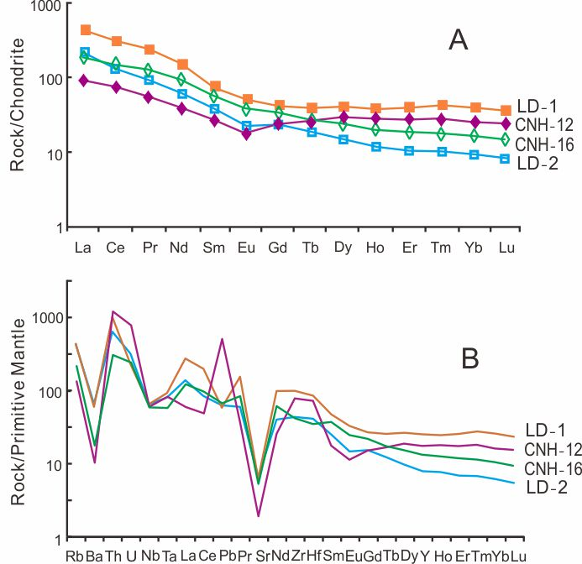

8. Plots of immobile element discriminant of the Langdai and Chinahe K-bentonites and some other K-bentonites in terrestrial to littoral environment in western Guizhou (**from Tables 1 and 2**).

